The community support information is tabulated as below:

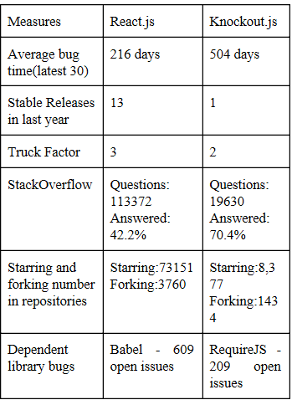

The references are:

<http://gittrends.io/#/repos/facebook/react>

<http://gittrends.io/#/repos/knockout/knockout>

http://gittrends.io/#/repos/facebook/react

http://gittrends.io/#/repos/knockout/knockouhttp://gittrends.io/#/repos/facebook/react

http://gittrends.io/#/repos/knockout/knockout

http://gittrends.io/#/repos/facebook/react

http://gittrends.io/#/repos/knockout/knocko